**Assignment : Archive Old Files from S3 to Glacier Using AWS Lambda and Boto3**

S3 Setup

Creating a S3 bucket with files uploaded to it.

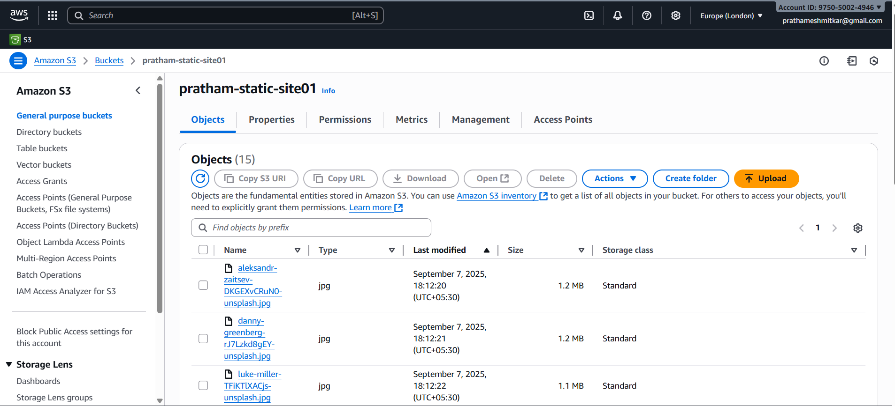

Create IAM role for Lambda

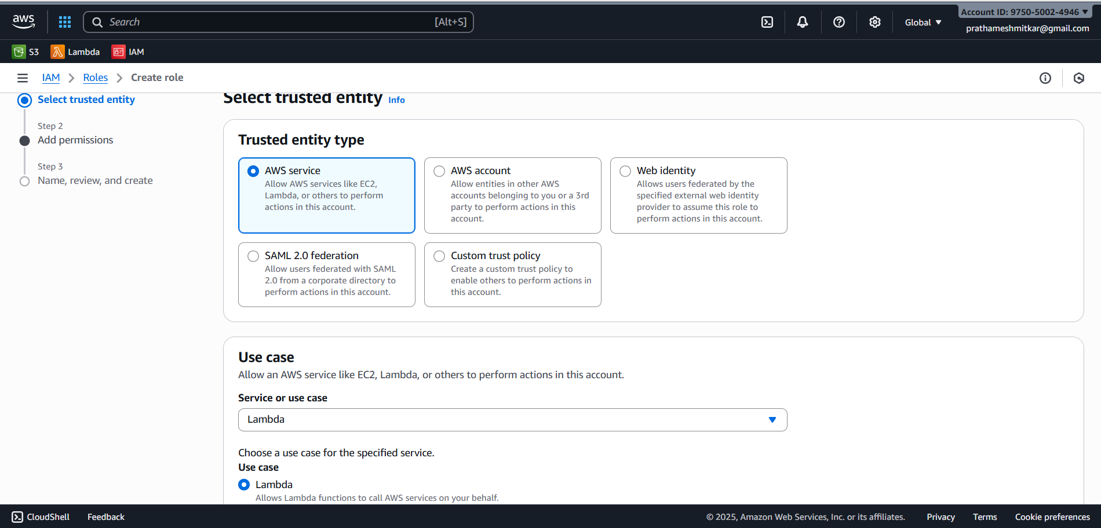

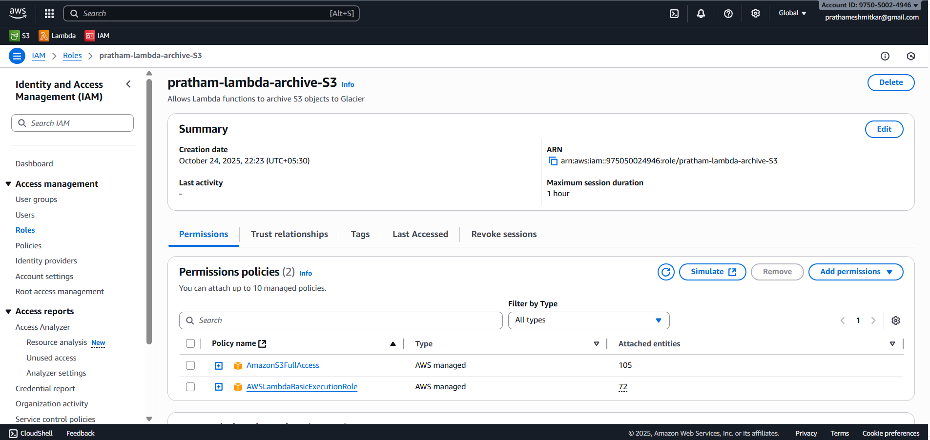

Create Lambda function

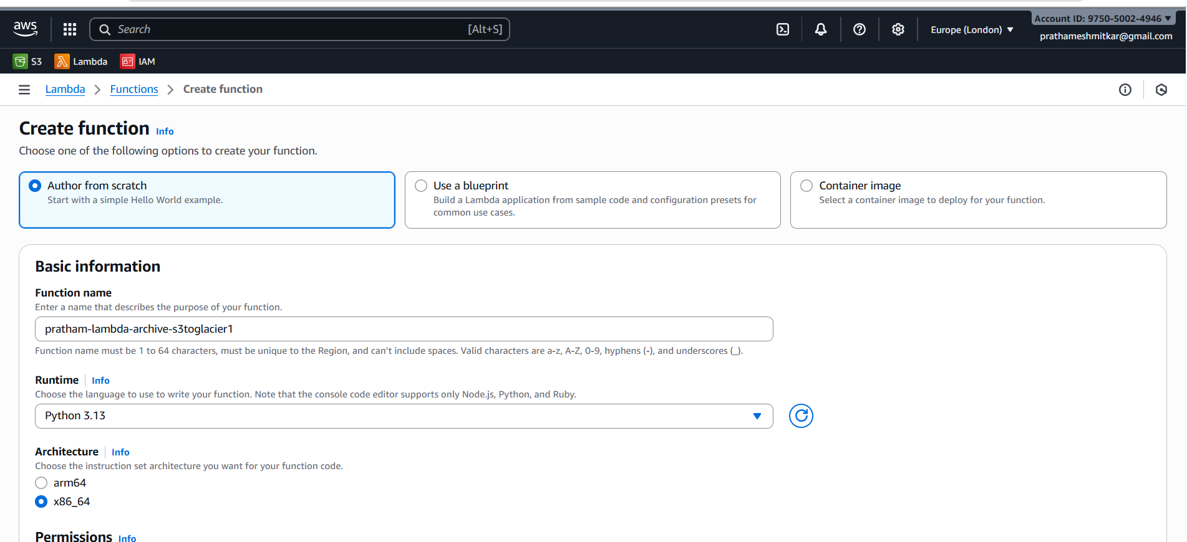

Adding environment variables to lambda.

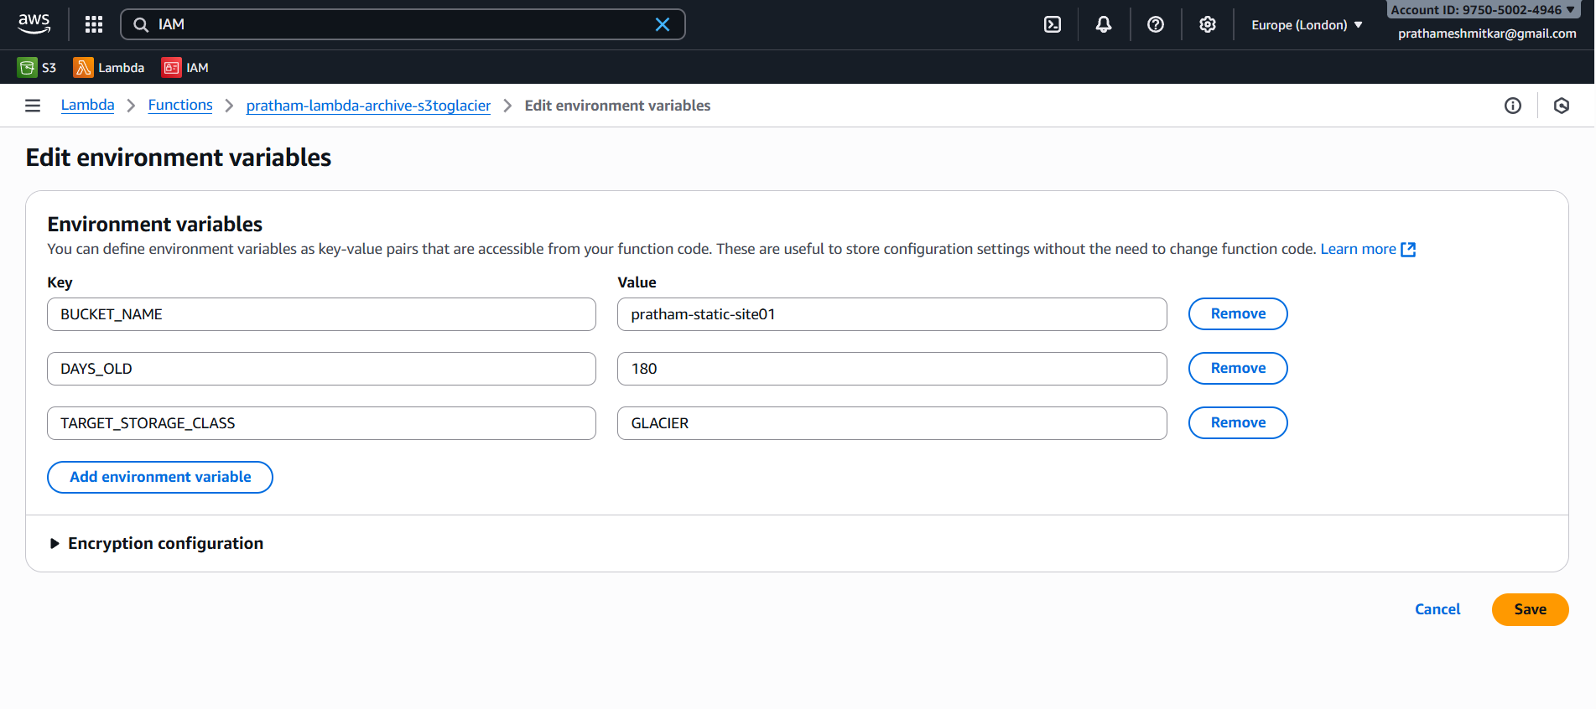

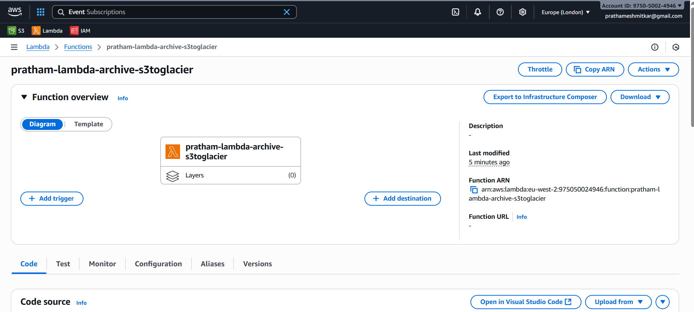

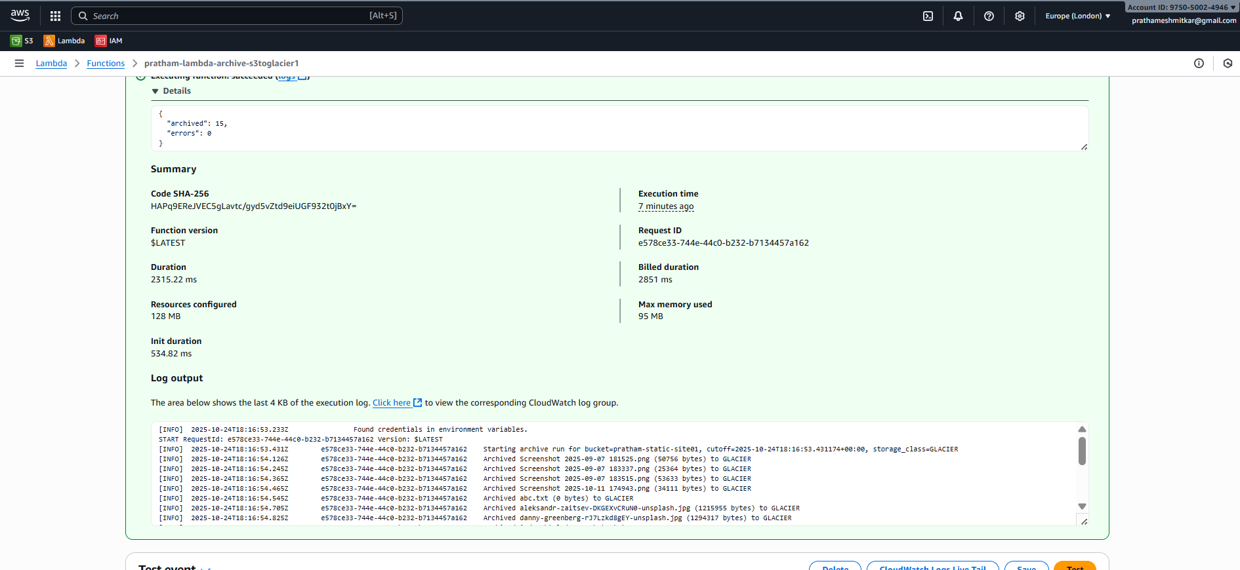

Python code, Cloudwatch logs for Lambda and screenshot of S3 bucket after archiving for Lambda

 

